**Docker Task -2**

**Task Description:**

Create a dockerfile, docker-compose file which when executed must display your basic details in the website

**Steps:**

1.Create these files:

* package.json
* index.js
* Dockerfile
* docker-compose.yml

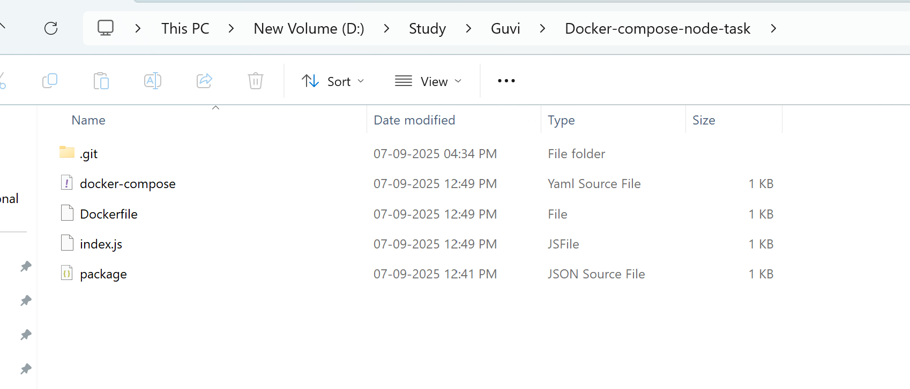

2.Launch an AWS EC2 Instance

Go to AWS EC2 Console

Launch a new instance:

• Security group: allow ports 22 (SSH) and 80 (HTTP)

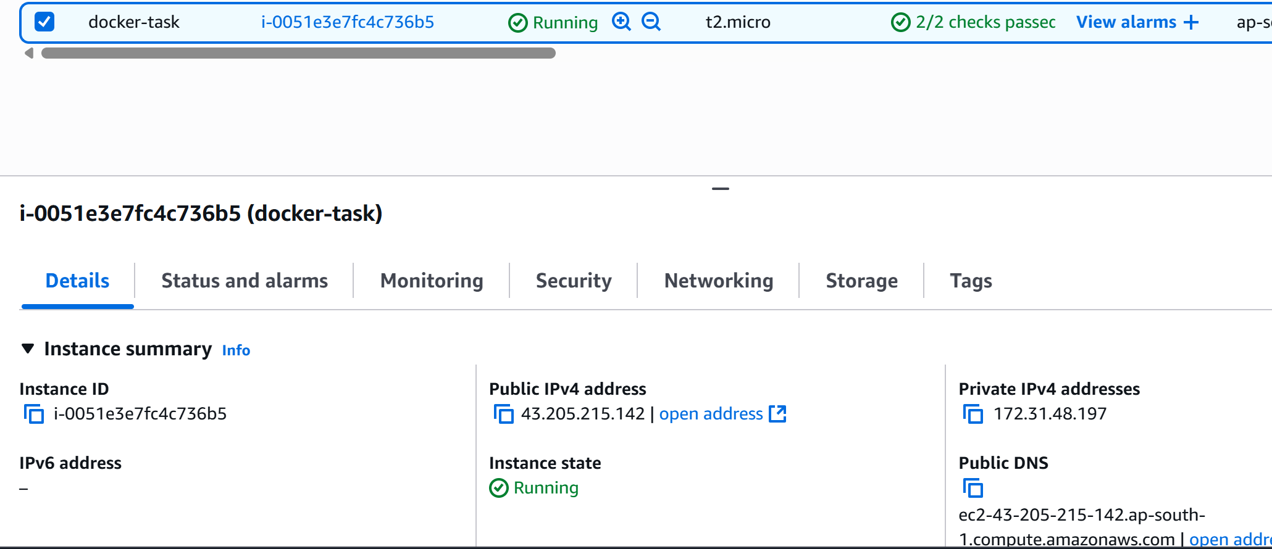

Download key file

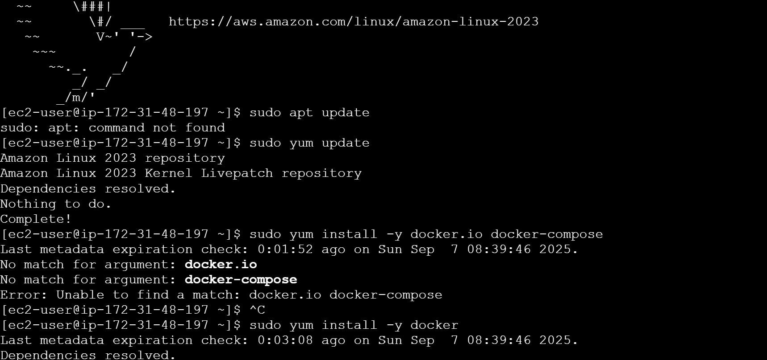

sudo yum update

sudo yum install -y docker

sudo systemctl start docker

sudo systemctl enable docker

3.Move the sourcecode to GIT repository

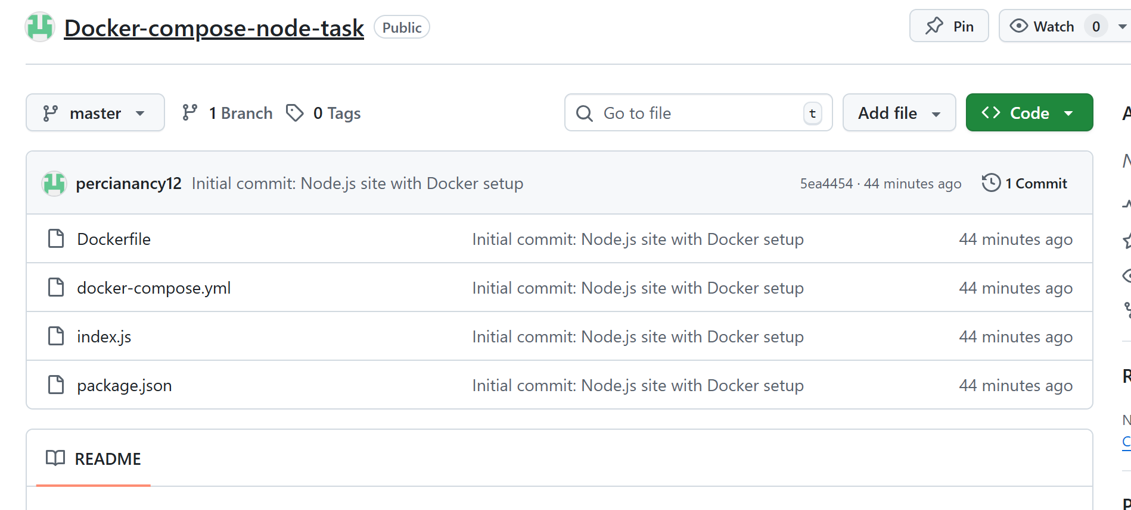

4.Connect EC2 using pem file in local machine

ssh -i "docker-task.pem" ec2-user@ec2-43-205-215-142.ap-south-1.compute.amazonaws.com  
  
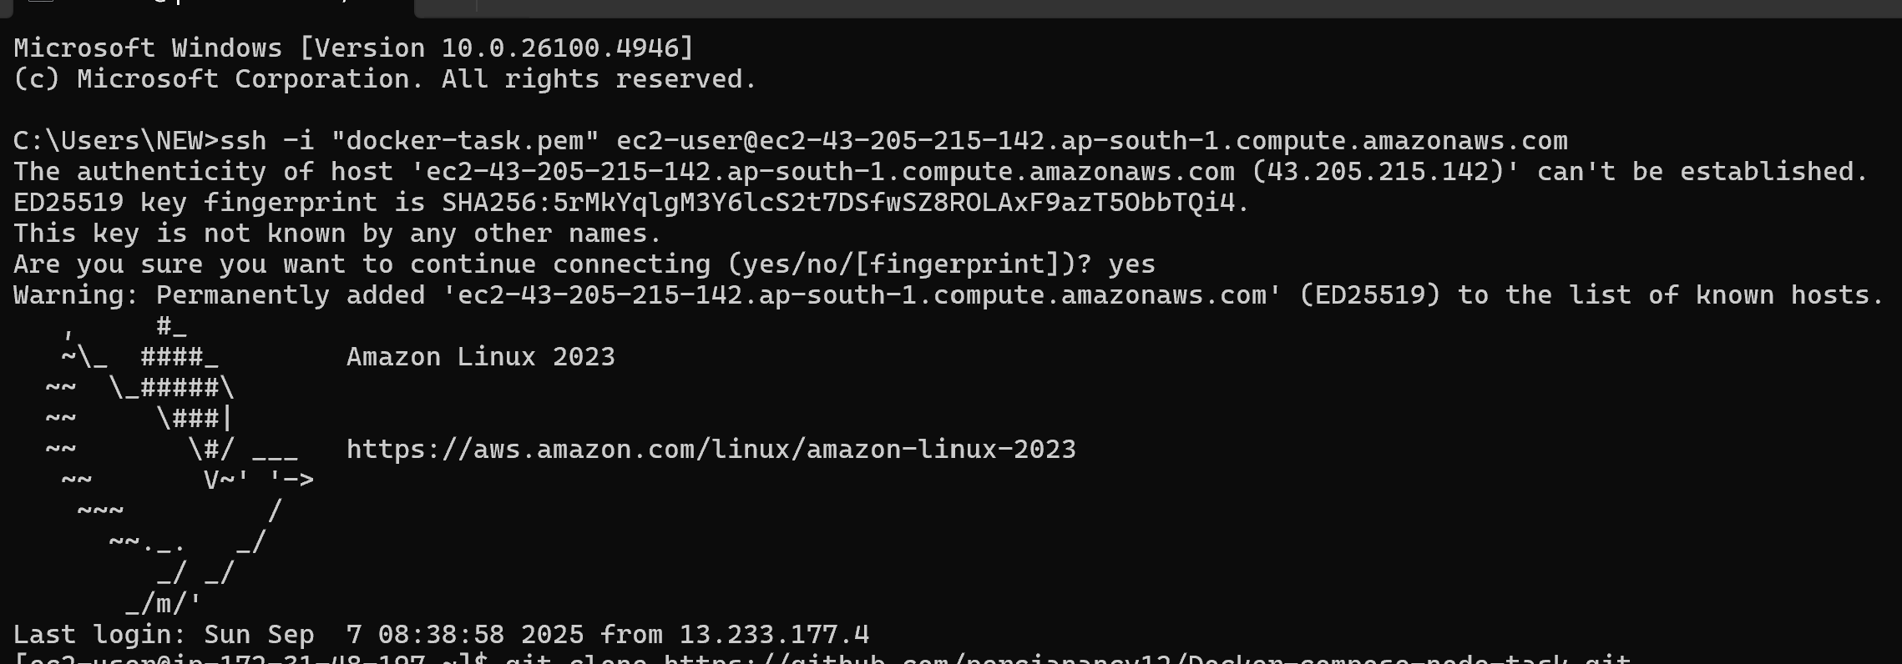

5.Install GIT in EC2

sudo yum install git -y

git clone https://github.com/percianancy12/Docker-compose-node-task.git

Clone the repo in EC2  
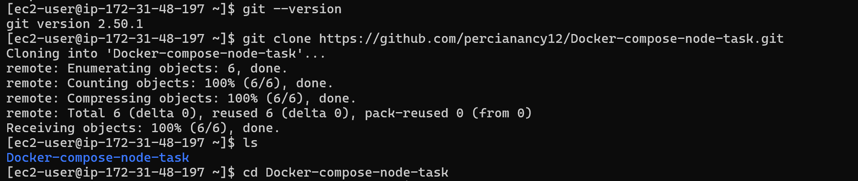

6.Install Docker Compose

Run these commands inside your EC2 terminal:

sudo curl -L "https://github.com/docker/compose/releases/latest/download/docker-compose-linux-x86_64" -o /usr/local/bin/docker-compose

sudo chmod +x /usr/local/bin/docker-compose

docker-compose version

This will:

- Download the latest Docker Compose binary

- Make it executable

- Confirm it’s installed

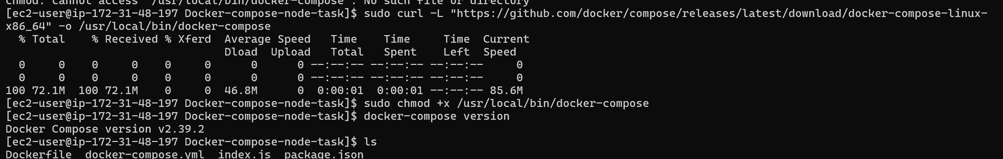

7.Run Your Docker App

Now run this:

sudo docker-compose up --build -d

This will:

- Build your Docker image

- Start the container

- Run your Node.js app in the background

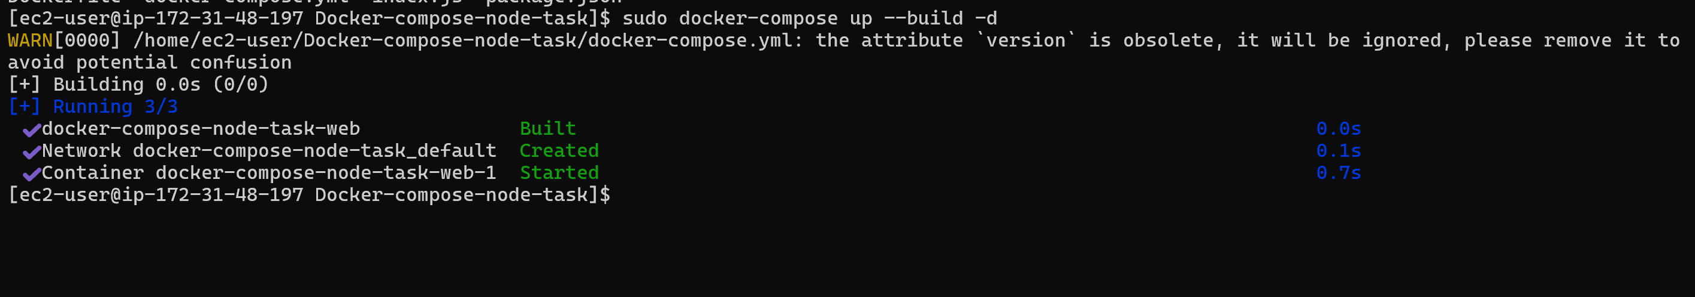

8.Access the Node js app using EC2 public IP

